TITLE: VOLTUS INSIGHT AI

Github URL: https://github.com/kdharani242-source/Voltus-insightAI
Abstract: Voltus Insight AI is a VLSI-based project developed using Cadence Voltus for power integrity analysis and optimization. The project focuses on analyzing IR drop, power consumption, and voltage distribution in digital integrated circuits through simulation. AI-based analytical concepts are used to identify power hotspots and provide optimization insights. The project mainly works at the simulation level to study power behavior and reliability in VLSI systems. This project helps in understanding advanced power analysis techniques used in modern semiconductor design.
Introduction: In modern VLSI design, power integrity plays an important role in maintaining circuit performance and reliability. As semiconductor technology advances, integrated circuits become more complex and consume higher power. Problems such as IR drop, voltage fluctuations, and power hotspots can affect the efficiency of digital systems. Cadence Voltus is an advanced EDA tool used for power analysis and reliability verification in VLSI circuits. The “Voltus Insight AI” project focuses on analyzing power distribution and identifying power-related issues through simulation. The project performs static and dynamic power analysis to study voltage behavior in digital ICs. AI-based analytical concepts are used to generate insights for improving power optimization. The project mainly works at the simulation level using Cadence Voltus. It helps in understanding modern power integrity analysis techniques used in semiconductor industries. This project also improves knowledge about low-power and reliable VLSI system design.
Problem Statement: In modern VLSI circuits, increasing transistor density and power consumption create major challenges in maintaining power integrity. Issues such as IR drop, voltage fluctuations, and power hotspots can reduce circuit performance and reliability. Traditional analysis methods may require more time and manual effort to identify these problems. The Voltus Insight AI project aims to analyze power distribution and detect power-related issues using Cadence Voltus simulations. The project also uses AI-based analytical concepts to provide insights for improving power efficiency and reliability.
Objectives:
- To study power integrity issues in VLSI circuits.
- To analyze IR drop and power consumption using Cadence Voltus.
- To identify voltage drop regions and power hotspots through simulation.
- To understand static and dynamic power analysis techniques.
- To use AI-based analytical concepts for power optimization insights.
- To improve reliability and efficiency in digital IC designs.

Metodology:
Step 1: Design Preparation
- The digital IC design is prepared and imported into the Cadence environment.
- Required files such as netlists, libraries, and technology files are loaded.
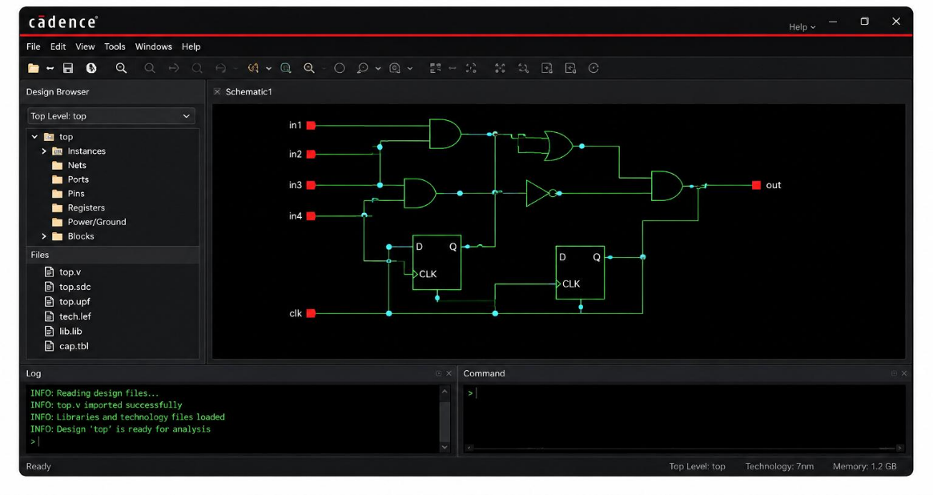

Step 2: Power Grid Configuration
- Power and ground networks are defined for the circuit.
- The power distribution setup is configured for analysis.
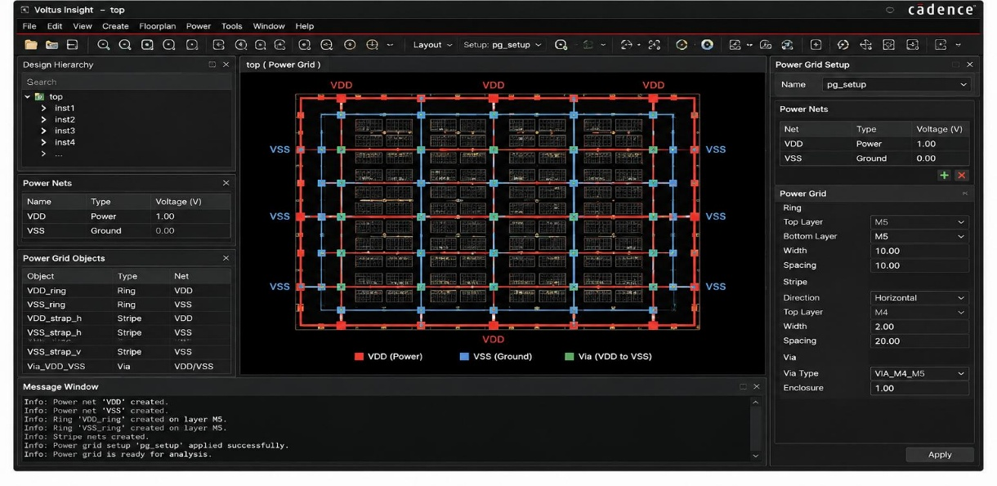

Step 3: Static Power Analysis
- Static power analysis is performed using Cadence Voltus
- Leakage power and overall power consumption are analyzed.
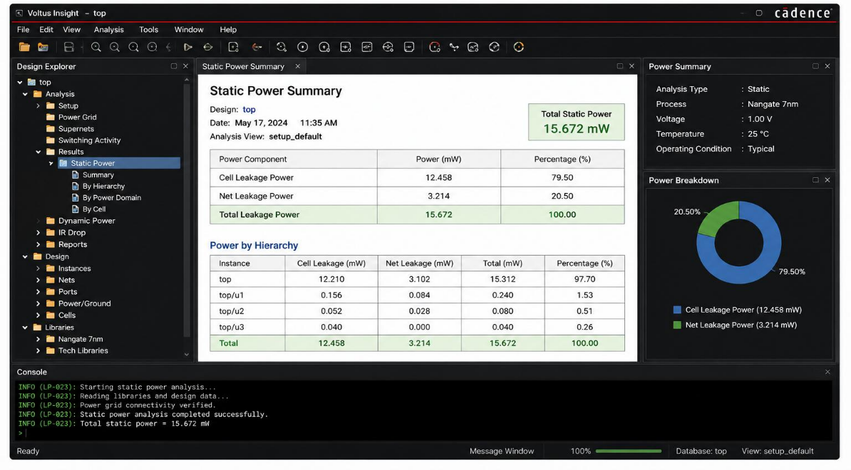

Step 4: Dynamic Power Analysis
- Dynamic power analysis is carried out to study switching activity.
- Voltage behavior during circuit operation is observed.
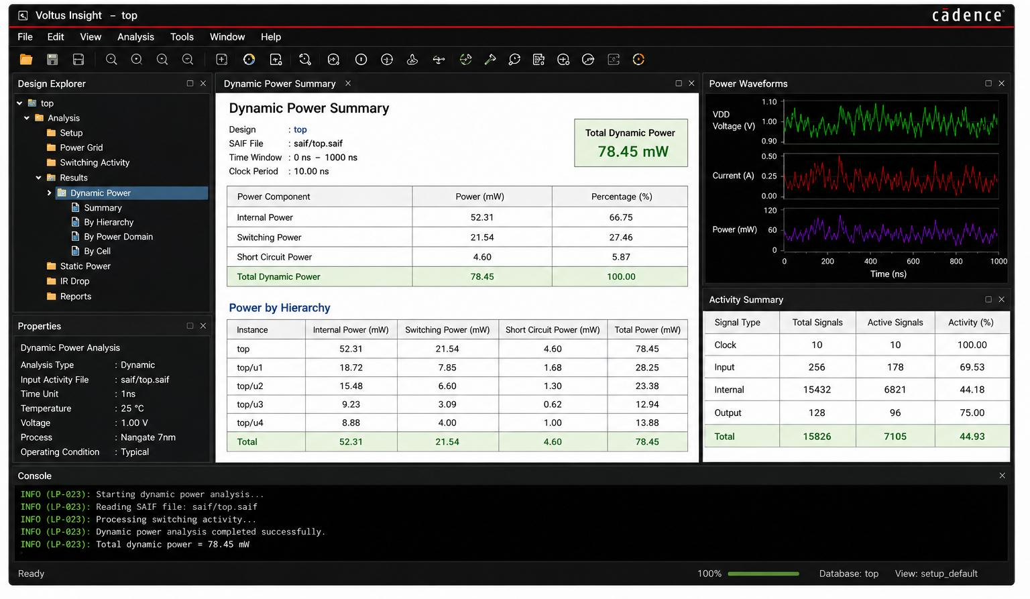
Step 5: IR Drop Analysis
- IR drop analysis is performed to identify voltage drop regions.
- Weak areas in the power network are detected.
Step 6: Hotspot Identification
- Power hotspots and high-power regions are identified through simulation reports.
- Critical regions affecting reliability are analyzed.

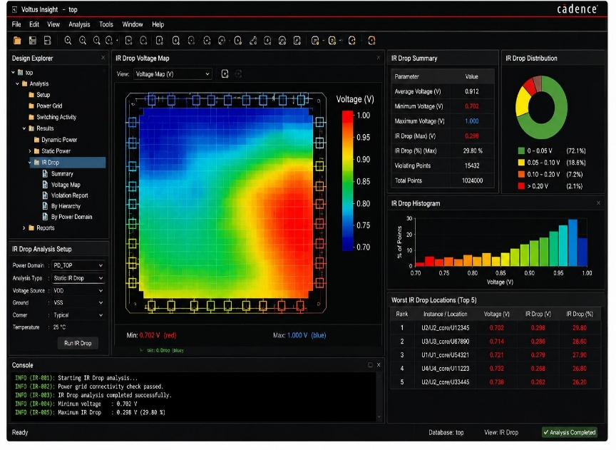
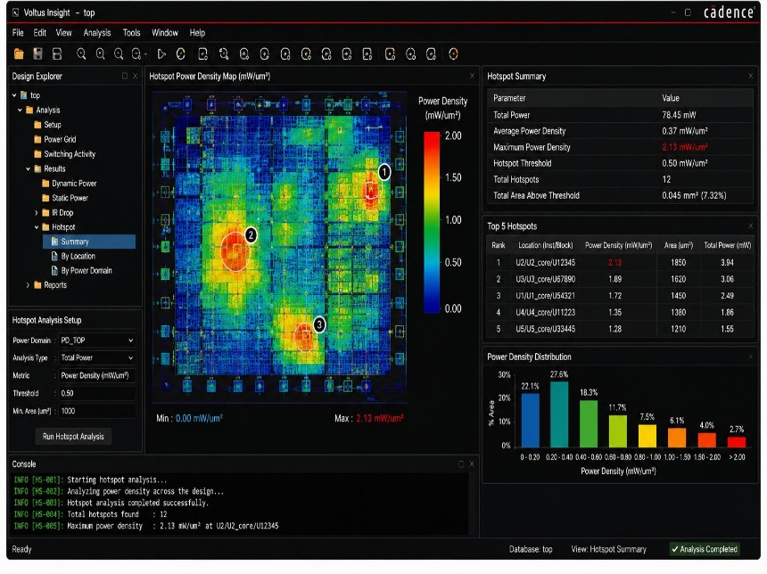
Step 7: AI-Based Insight Generation
- AI-based analytical concepts are used to study simulation patterns.
- Optimization suggestions are generated for better power efficiency.
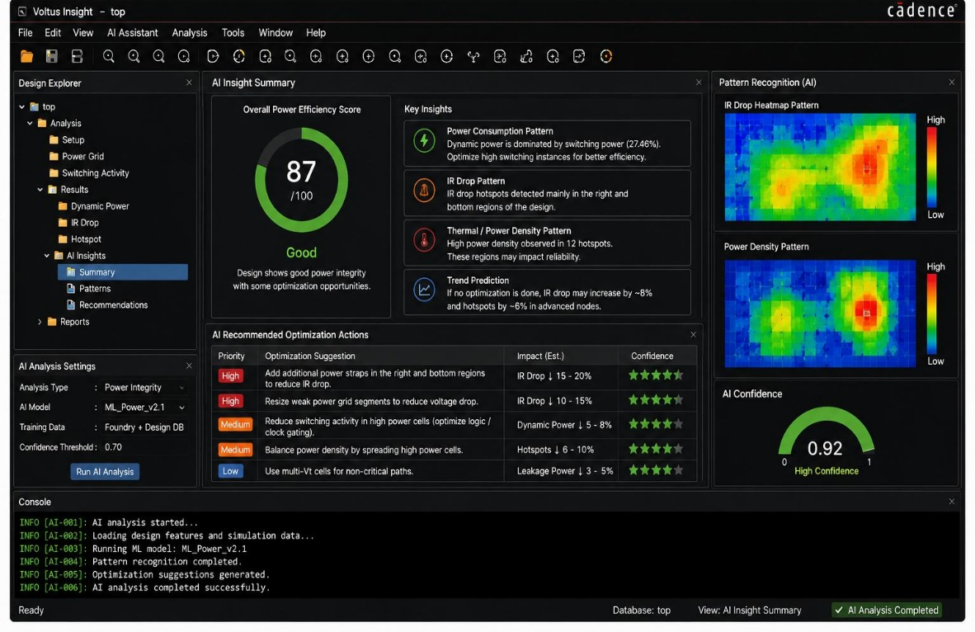

Step 8: Result Analysis
- Final simulation reports and outputs are analyzed.
- The overall performance and reliability of the design are evaluated.

Tools and Technologies
Software Tool:
Cadence Voltus
- Used for power integrity analysis and reliability verification.
- Performs static and dynamic power analysis.
- Helps in IR drop and hotspot detection.
- Used for analyzing power distribution in VLSI circuits.
Technologies
- VLSI Design
- CMOS Technology
- Power Integrity Analysis
- Electronic Design Automation (EDA)
- AI-Based Analytical Concepts
- Low Power Design Techniques
Conclusion:
The “Voltus Insight AI” project successfully demonstrates power integrity analysis in VLSI circuits using Cadence Voltus. The project focuses on analyzing IR drop, power consumption, voltage distribution, and hotspot regions through simulation. AI-based analytical concepts are used to generate optimization insights for improving power efficiency and reliability. The simulation results help in understanding modern low-power VLSI design techniques and the importance of proper power distribution networks. Overall, this project provides valuable knowledge about advanced power analysis methodologies used in semiconductor industries.

